Task-3

Objective:- Install Ubuntu on virtual machine

Step 1:- Download and install Oracle VM virtual box

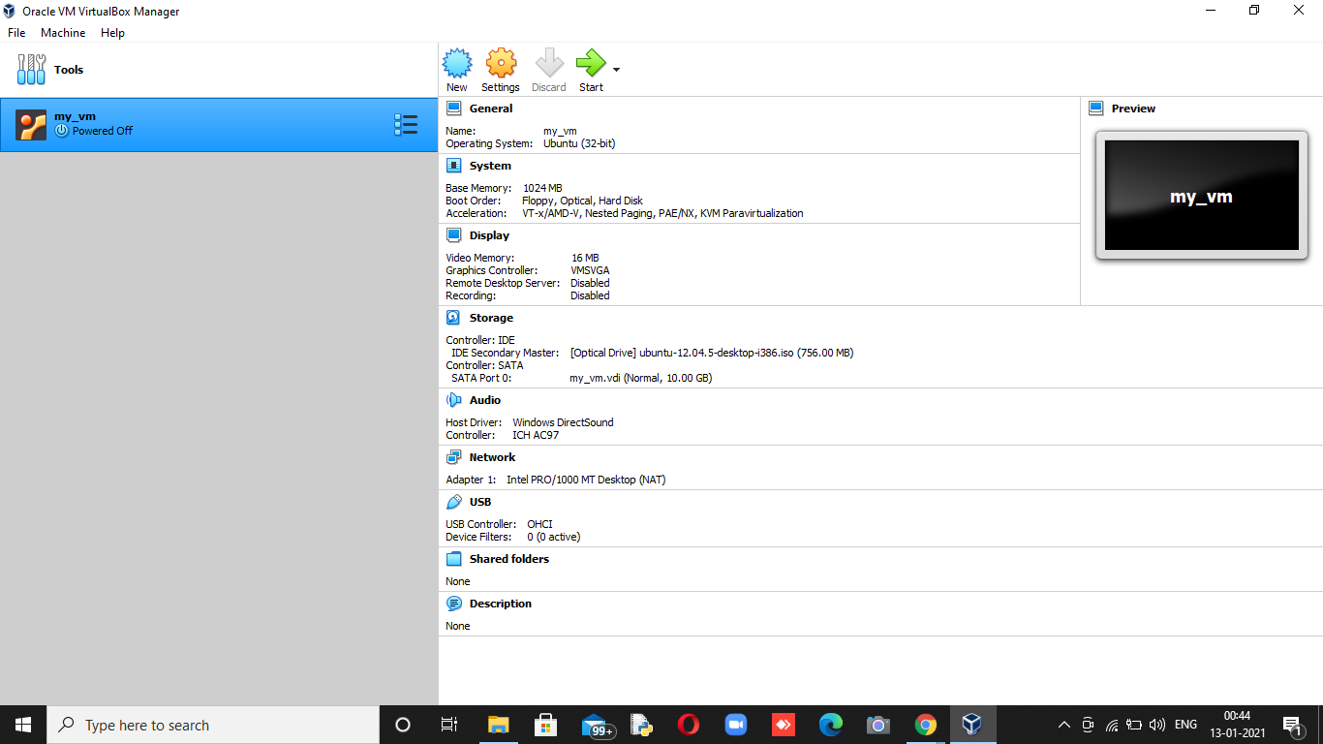

Step 2:- Download image of Ubuntu and configure the virtual box setting regarding it.

Step 3:- Click on start

